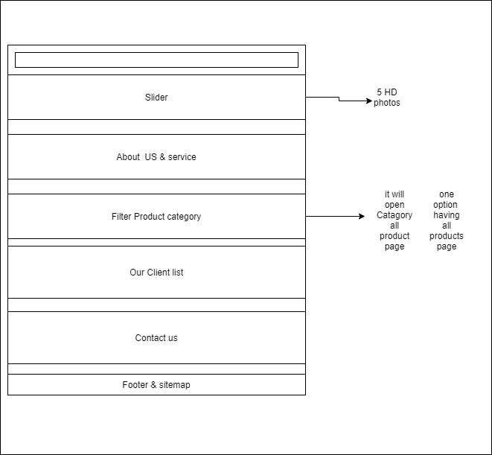

Product Page

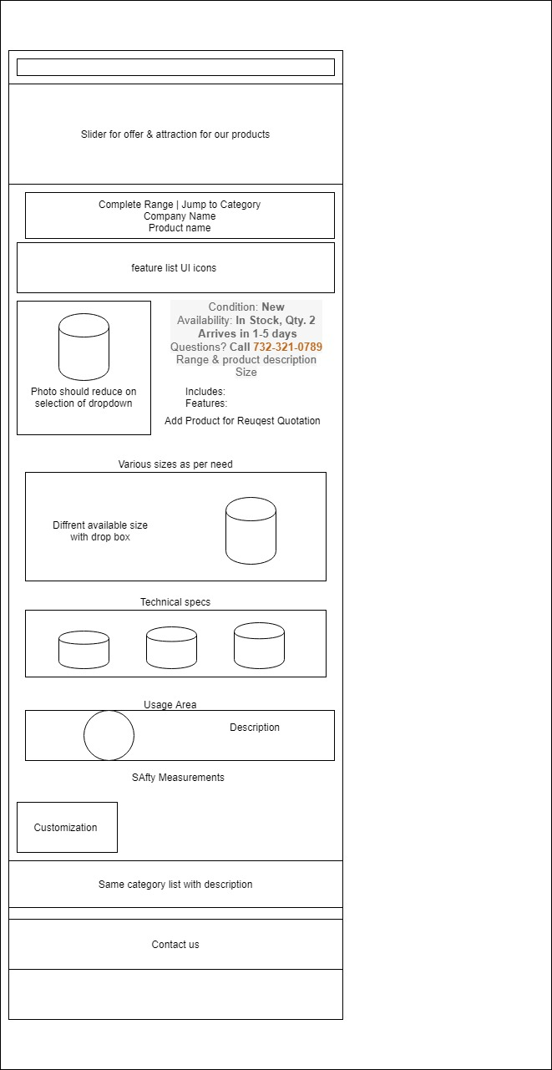

TRADE CAPABILITIES

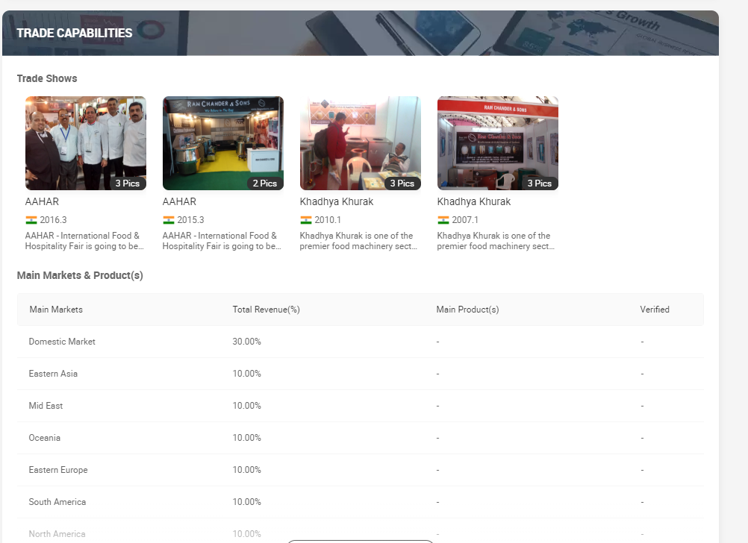

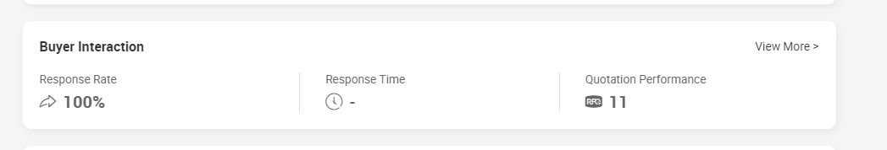

Restaurants, Hotels, Commercial

**Features:**• Efficiency• Sturdy construction• Highly durable standards